**SFTP to SFTP USING CPI**

**Table of Contents**

**Objective – SFTP to SFTP using CPI** 2

**Create end to end scenario.** 2

**Testing:** 14

**Revision History:**

|  |  |  |  |  |
| --- | --- | --- | --- | --- |
| **Version** | **Date** | **Author(s)** | **Reviewer** | **Revision Notes** |
| 1.0 | 15-Feb-2019 | Sidharth VR Sayantani Deb | Binod Kumar Mondal | First release of document |
|  |  |  |  |  |
|  |  |  |  |  |

# 

# **Objective – SFTP to SFTP using CPI**

The Objective of this Interface is to pick a file from source SFTP Server location and transfer the same to the target SFTP receiver folder.

# **Create end to end scenario.**

**Step 1:** Creation of Package

Please refer to the document attached.



\*\***NOTE**: “In case if the package is already created then skip this step and do not create package and directly go for “Integration Flow” creation.” **

**Step 1:** Create an Iflow and provide the details ***‘Name’*** and ***‘Description’***.

Name: ***File_to_File_Scenario_xxxx*** (Replace xxxx with your userid to maintain unique IFlows)

Description: ***IFlow for File to File Scenario*** (for example)

And click on ***‘OK’*** to create the IFLOW.

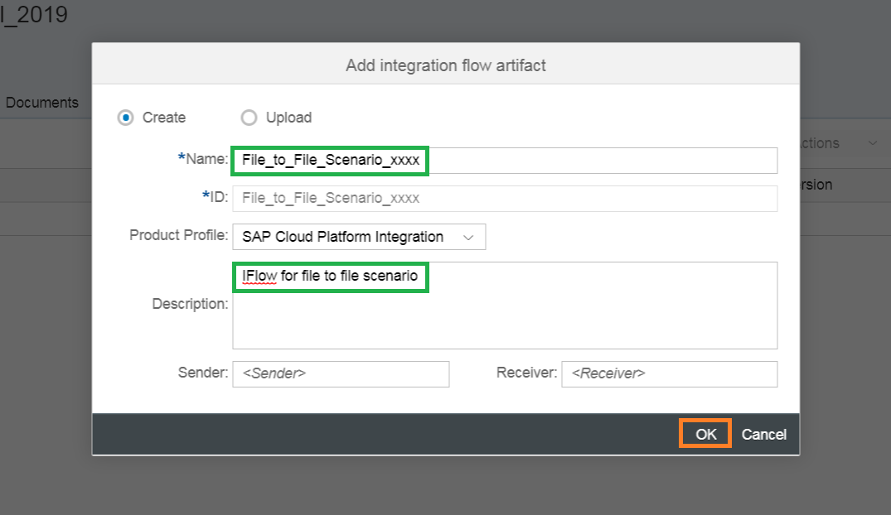

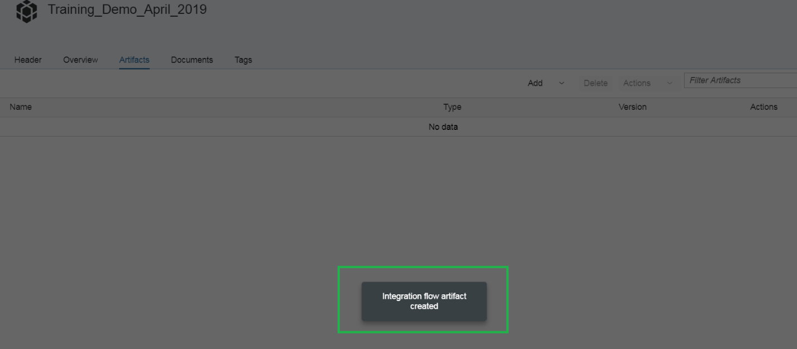

Your IFLOW is created.

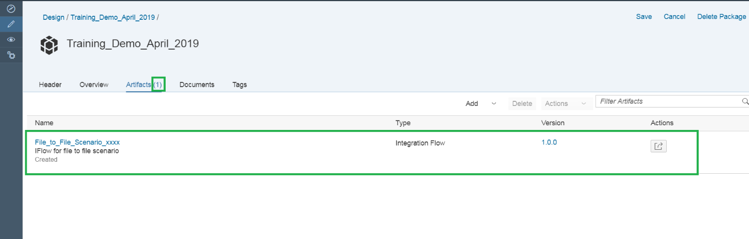

**Step 2:** Click on the IFlow created which is highlighted in green.

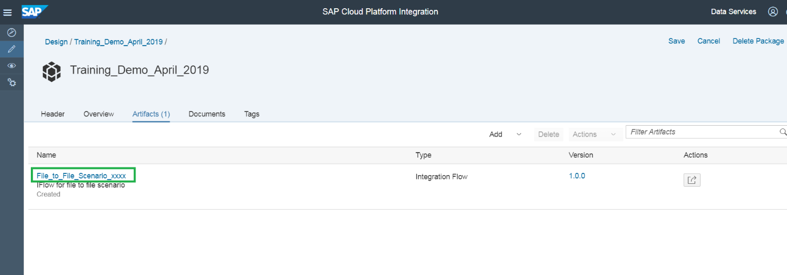

The IFLOW created:

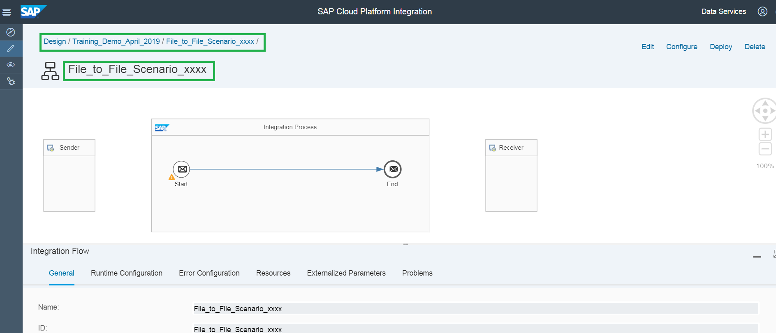

**Step 3:** Click on ***‘Edit’*** on the top right corner of the page to edit the IFLOW.

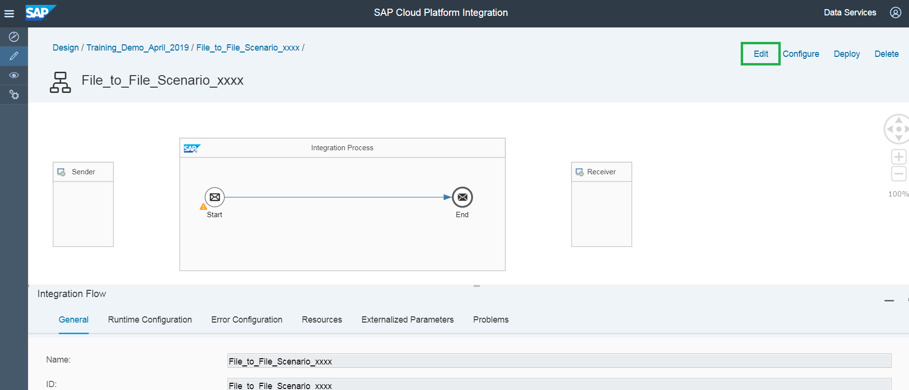

**Step 4:** Components of IFLOW required to create the File to File scenario

1. Sender
2. SFTP Sender Adapter
3. Content Modifier
4. SFTP Receiver Adapter
5. Receiver

**Step 5:** Sender and Receiver Systems

Click on ‘Edit’ and pick from the pallet on the left, the two participants🡪a Sender Participant and a Receiver Participant from the Pallet List.

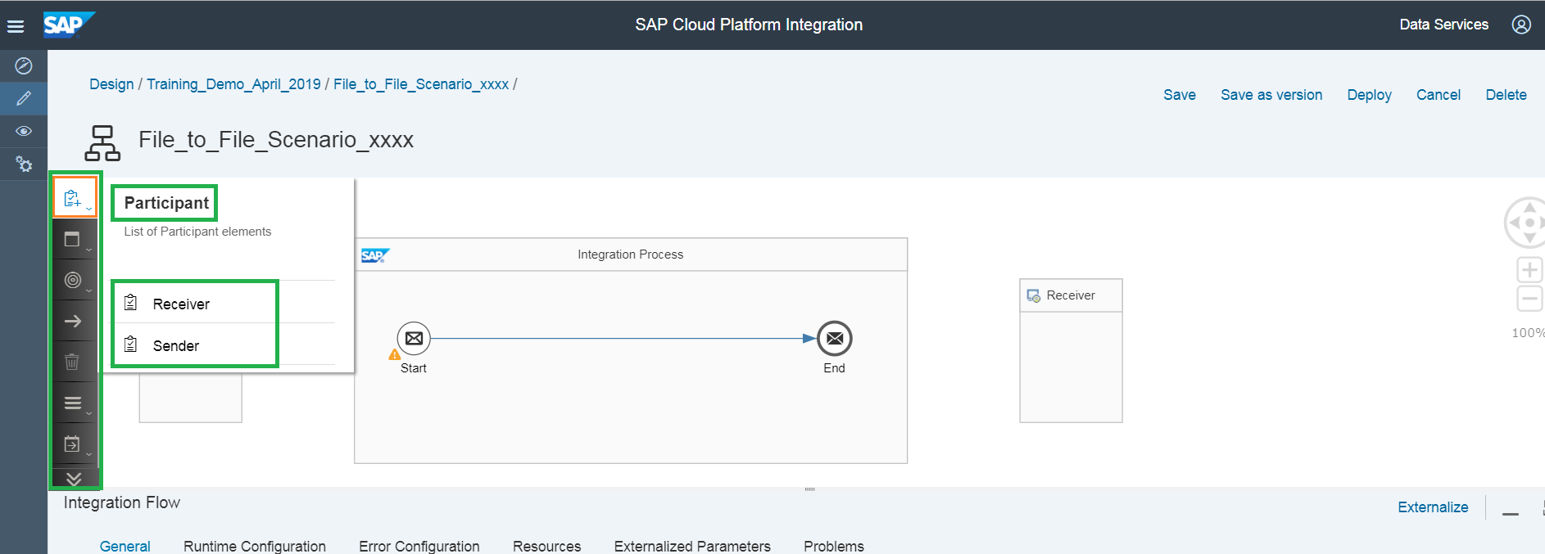

**Step 6:** Connect the Sender participant and Start message using SFTP Adapter.

Click on the Sender system on the left of the Integration Process box. You can see the arrow which is highlighted in green. Join arrow from the ***‘Sender system’*** to ***‘Start Message’*** (Circle with an envelope inside and named as ‘Start’).

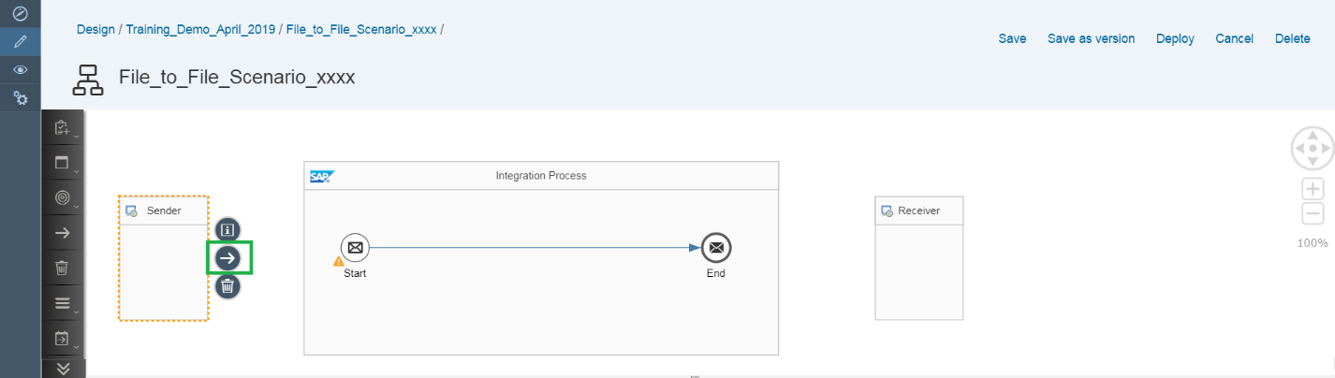

**Step 7:** Select the ***SFTP Adapter***.

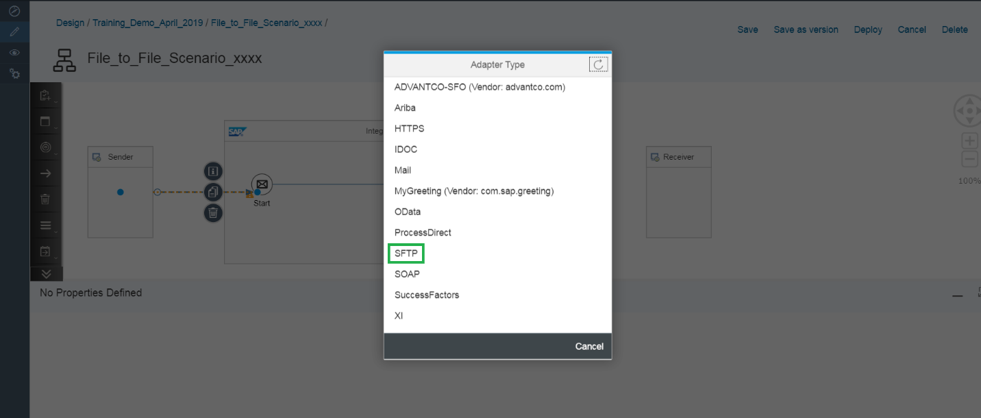

**Step 8:** Click on ***‘File’***. (Optional, if system pop up additional screen)

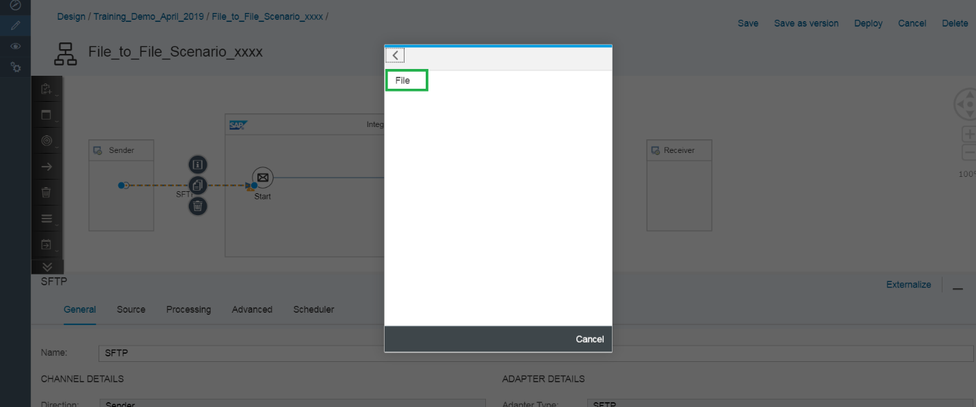

**Step 9:** Click on the sender dotted arrow connecting the Sender system and Start Message

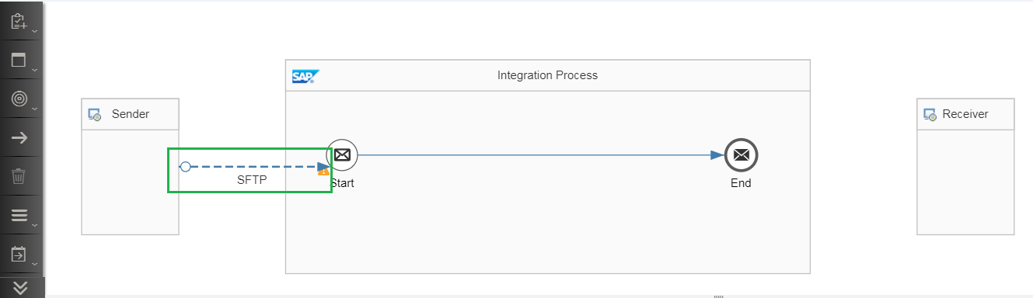

**Step 10:** Fill in the sender directory, filename, Address to SFTP server, Authentication and Credential Name. Select ***‘User Name/Password’*** from the drop list of ***‘Authentication’***.

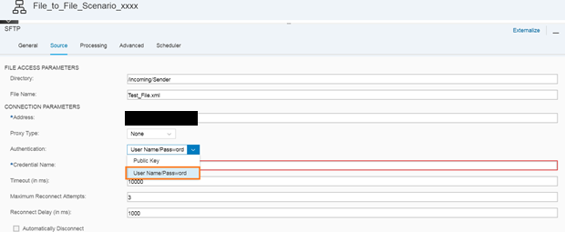

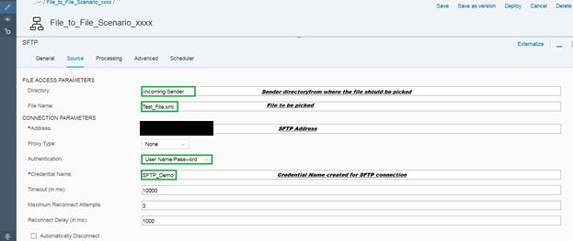

Directory: ***/incoming/Sender***

File Name: ***Test_File.xml***

Address: ***\*\*\*\*\*\*\*\*\*\*\*\*\*\*\*\****

Credential Name: ***SFTP_Demo***

**Credential Name Creation**

**Step 11:** Go to Monitor Tab>>Manage Security>>Security Material

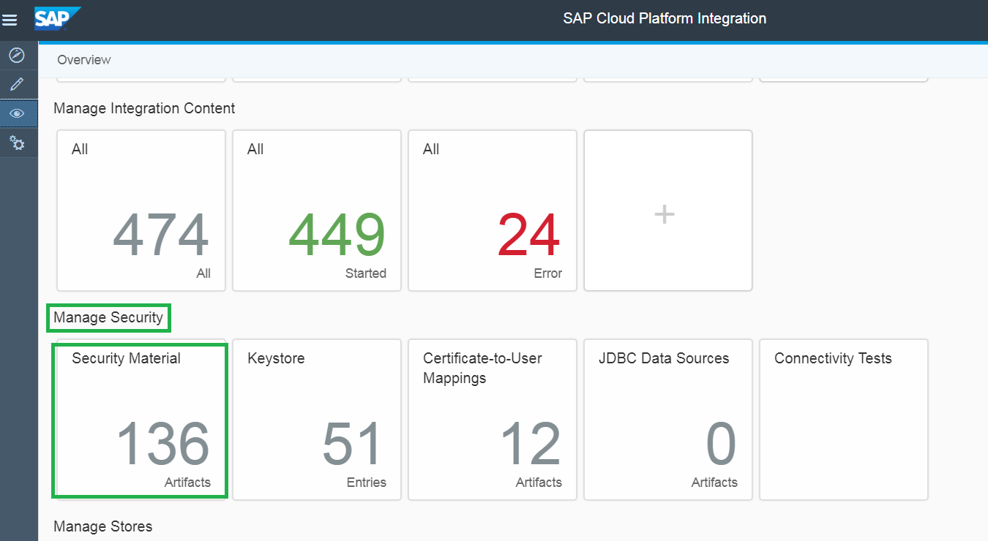

**Step 12:** Add a User Credentials to connect to SFTP server.

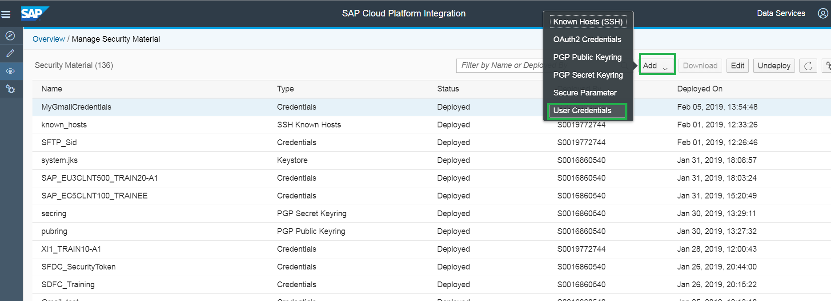

**Step 13:** Fill in the details and deploy the User Credential

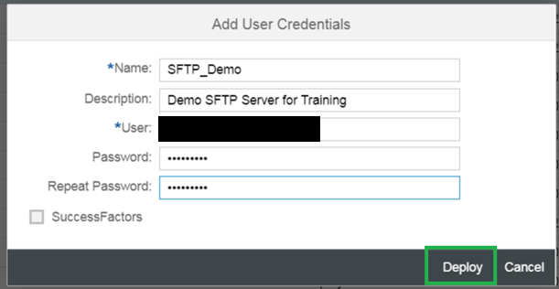

The Credential Name created:

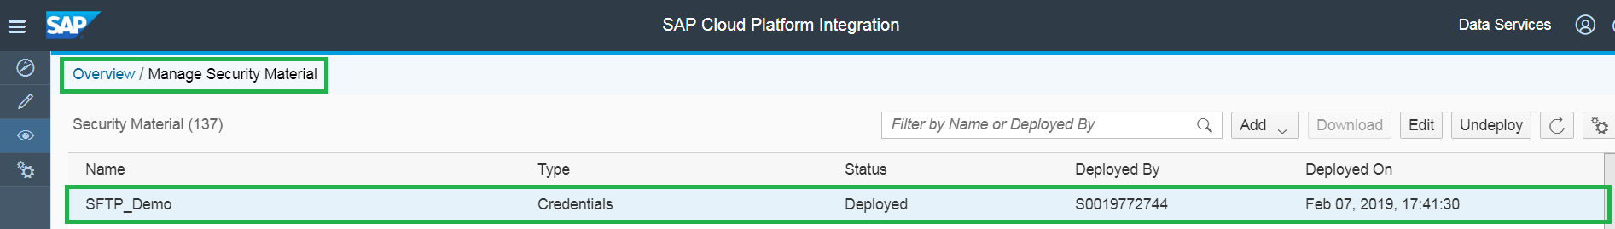

**Step 14:** Connection of End message to Receiver system

Similarly, Connect the End Message and Receiver SFTP Adapter.

Join arrow from the End Message to Receiver system and select the SFTP Adapter

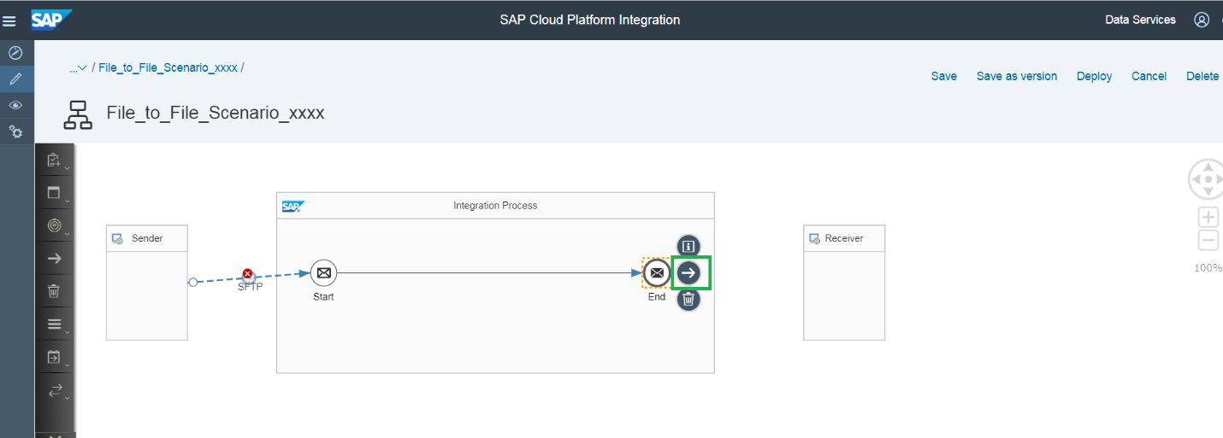

**Step 15:** Select ***‘SFTP’***.

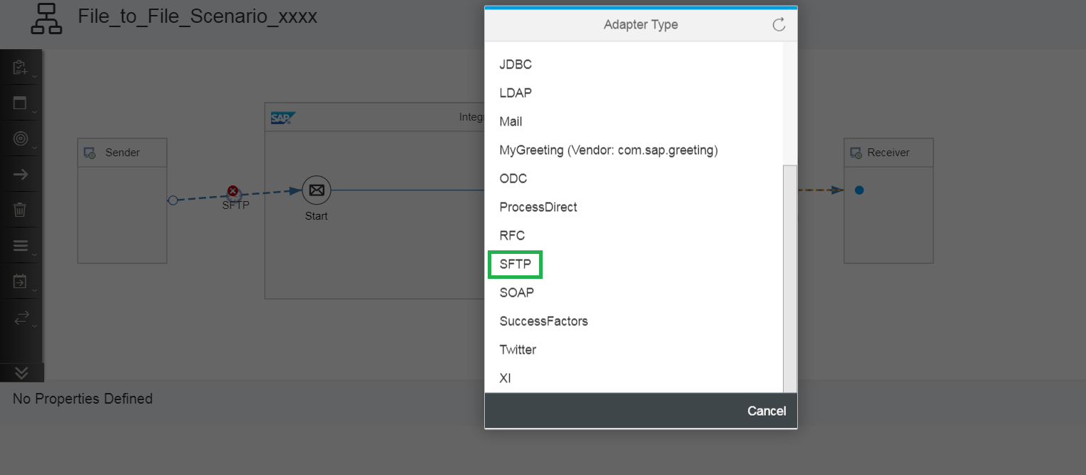

**Step 16:** Select ***‘File’***. (Optional, if system pop up additional screen)

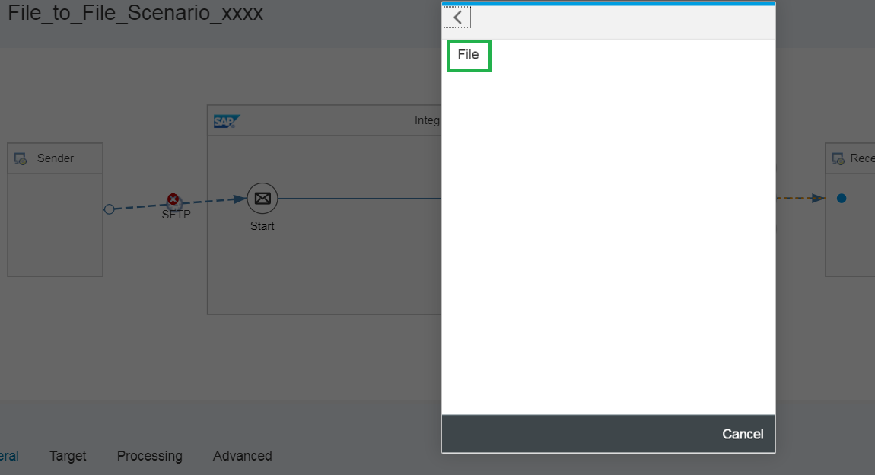

**Step 17:** Click on the dotted arrow connecting the End Message and Receiver system

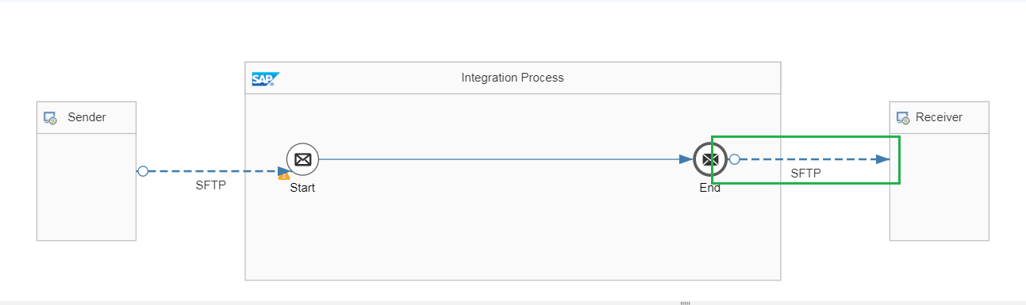

**Step 18:** Fill in the receiver directory, filename, Address to SFTP server, Authentication and Credential Name.

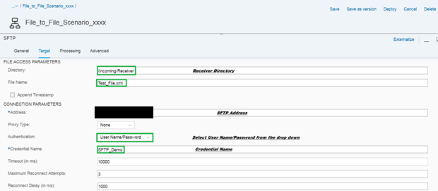

Directory: ***/incoming/Receiver***

File Name: ***Test_File.xml***

Address: ***\*\*\*\*\*\*\*\*\*\*\*\*\*\*\*\*\*\****

Credential Name: ***SFTP_Demo***

**Step 19:** Pick the Content Modifier from the Pallet under ***‘Transformation’*** and place the ***‘Content Modifier’*** between Start message and End message.

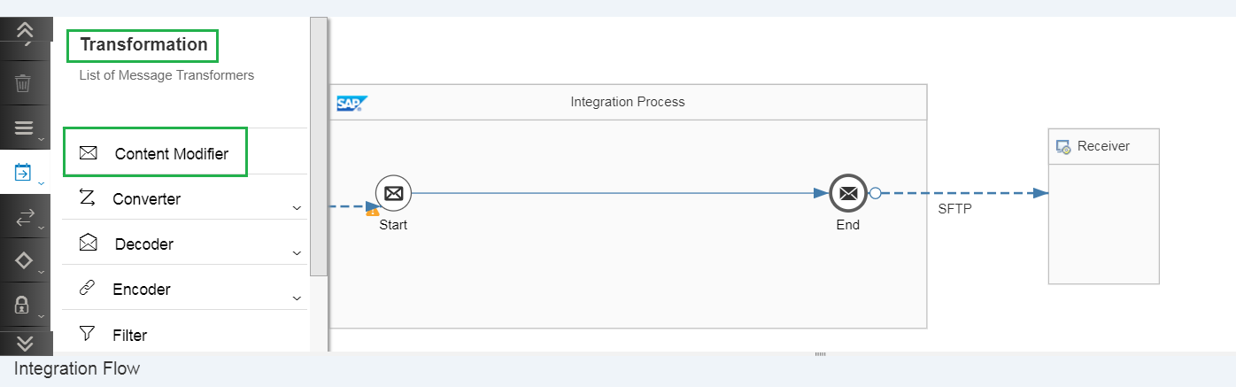

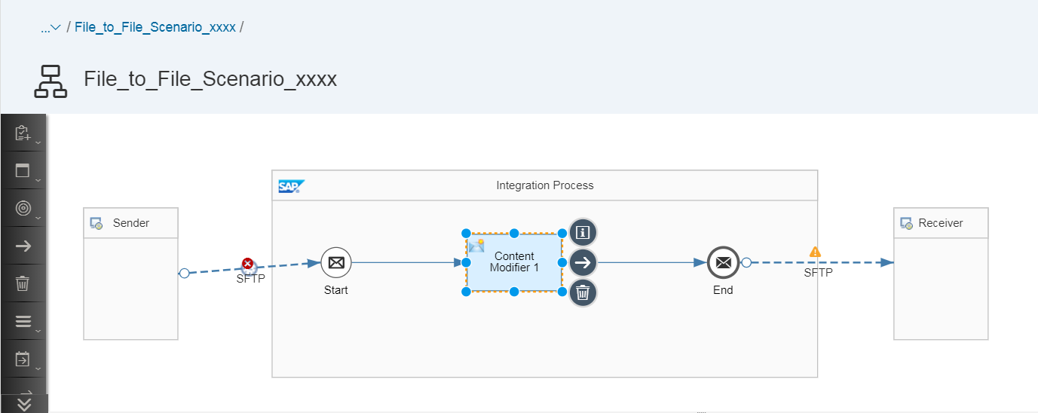

**Step 20:** Click on the ‘Content Modifier 1’ Box and click on the ***‘Add’*** button as highlighted below.

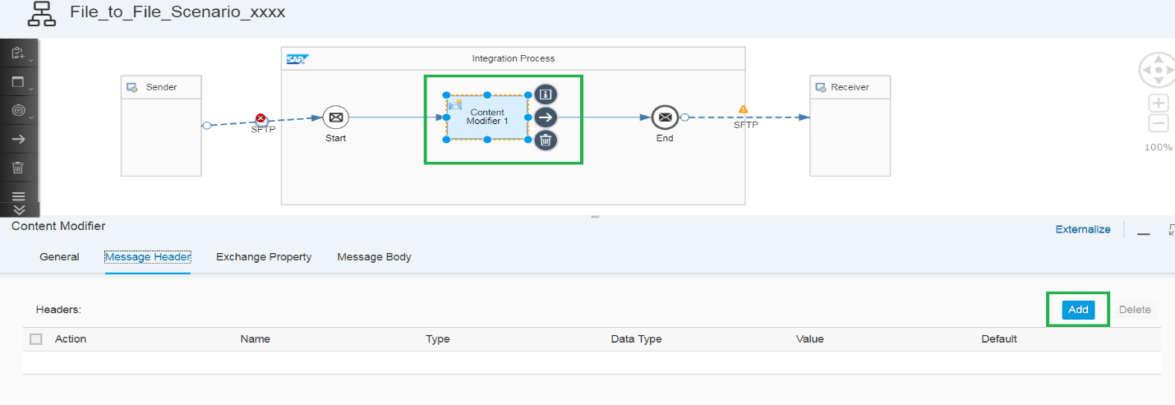

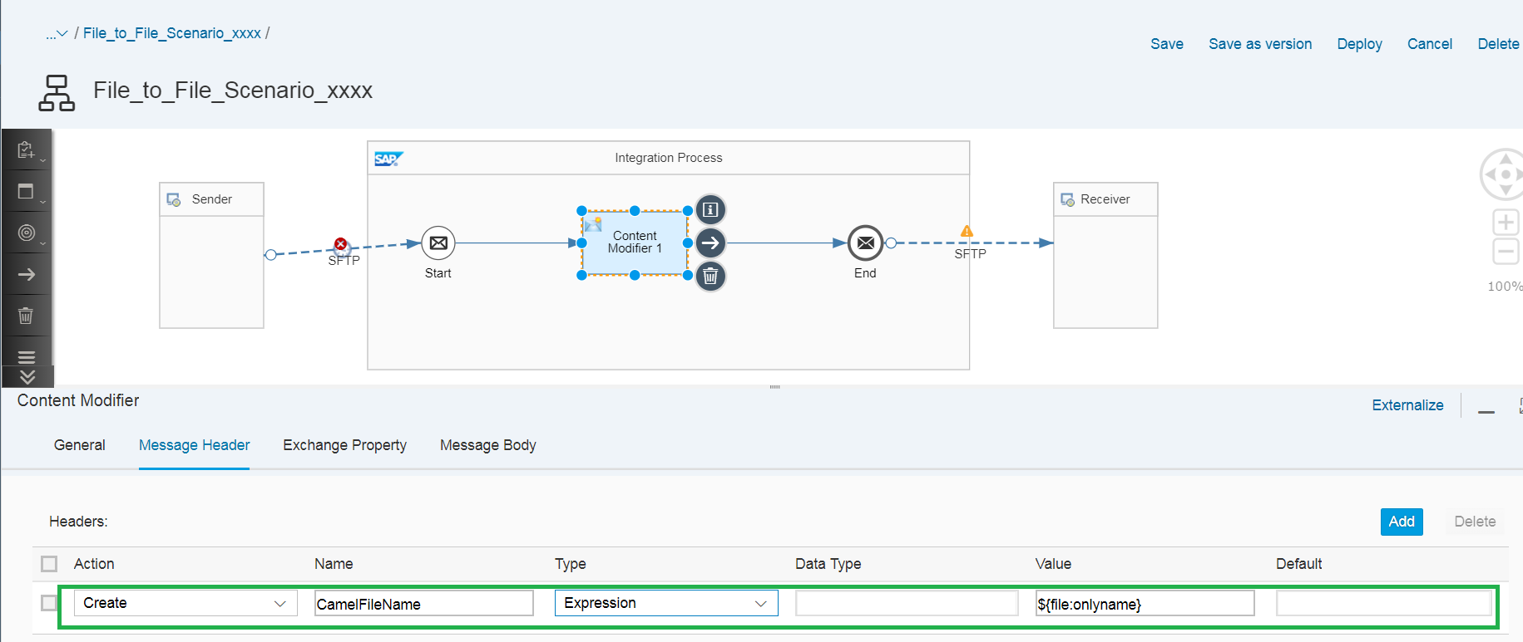

**Content Modifier** is used to modify a message by adding additional data to it. With Message Headers, we can add headers to it, edit and delete them.

Name: ***CamelFileName***

Type: ***Expression*** (From Drop-Down list)

Value: ***${file:onlyname}***

**Step 21:** Click on ***‘Save’***.

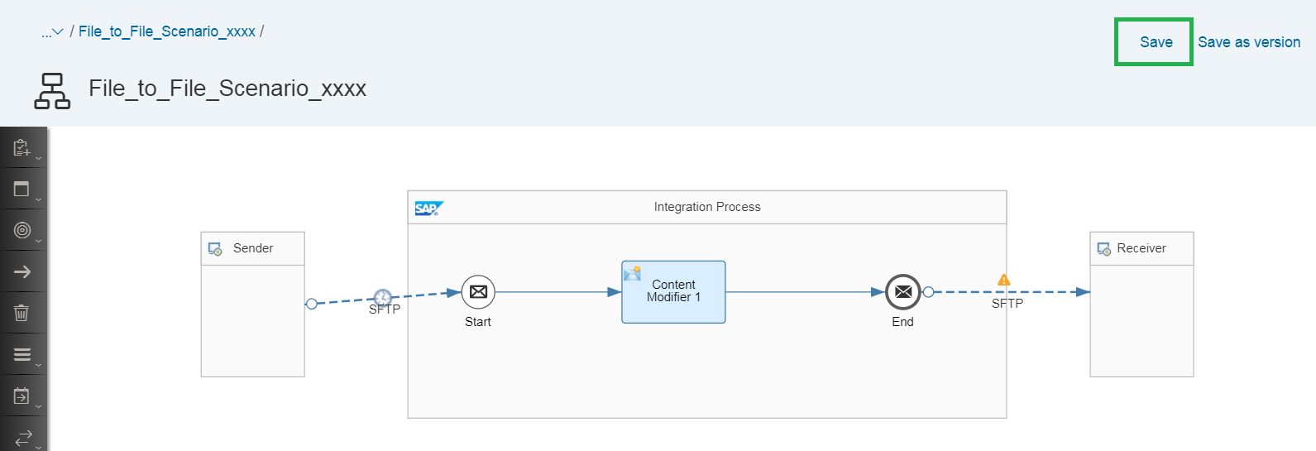

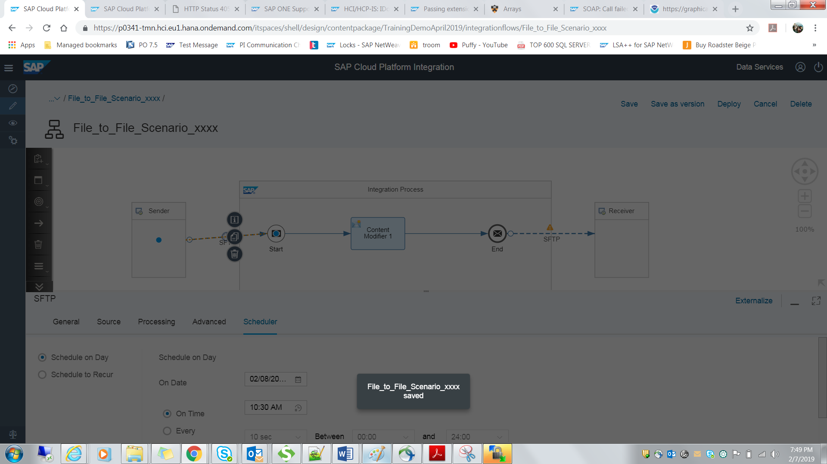

**Step 22:** Click on ***‘Deploy’*** to deploy the IFLOW.

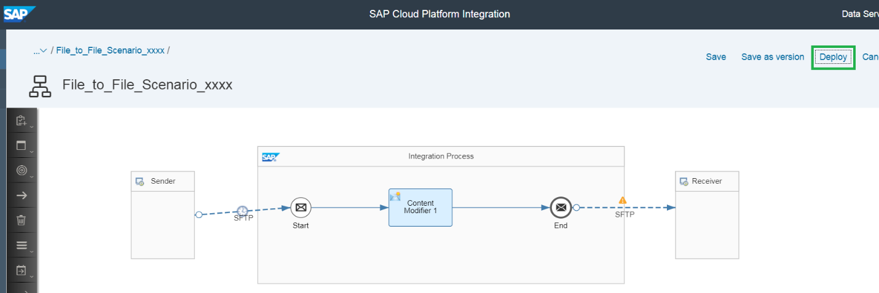

**Step 23:** Click on ***‘Yes’***.

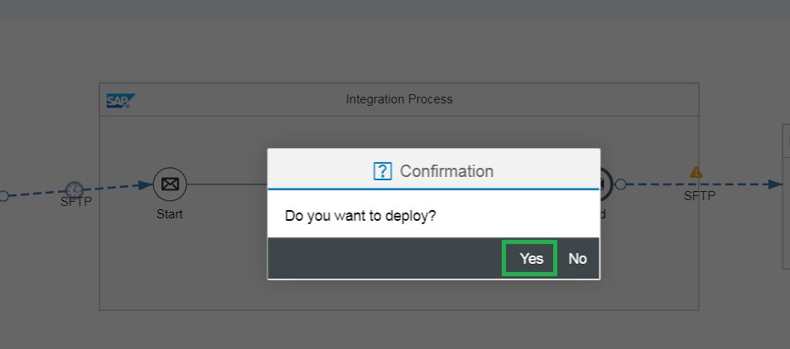

**Step 24:** Click on ***‘OK’***.

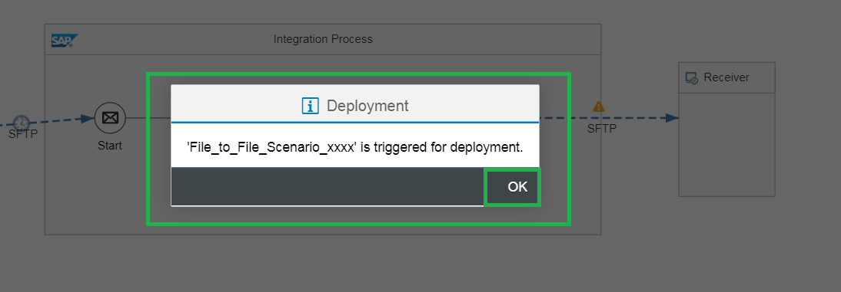

**It has been triggered for tomorrow’s date. The IFLOW will deploy on the next date.

# **Testing:**

**Step 25:** WinSCP Installation

Search ***‘Software Center’*** in list of programs in your local desktop. Click on it.

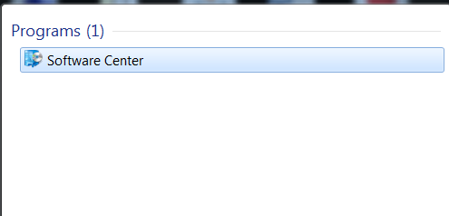

**Step 26:** Search ***‘WinSCP’*** in search bar on top right on the page and click on the ***‘WinSCP’*** highlighted in green.

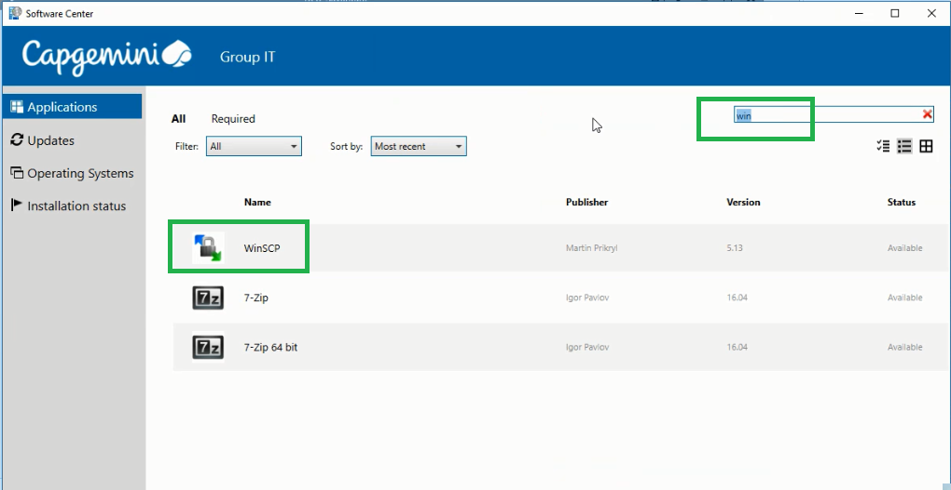

**Step 27:** Click on ***‘Install’*** and follow the steps of installation and save it in your desktop.

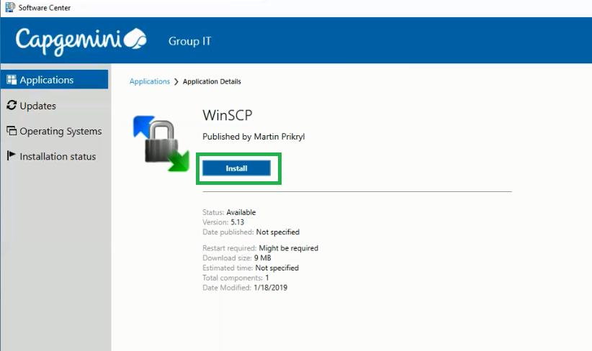

**Step 28:** You will find the below icon. Click on it to use the ***‘WinSCP’*** software.

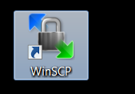

**Step 29:** Click on the WinSCP icon. You will get the below screen. Fill the ***‘Host Name’***, ***‘Username’*** and ***‘Password’***. Click on ***‘Login’***.

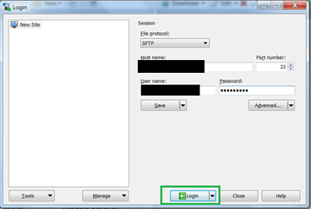

**Step 30:** Click on the incoming folder.

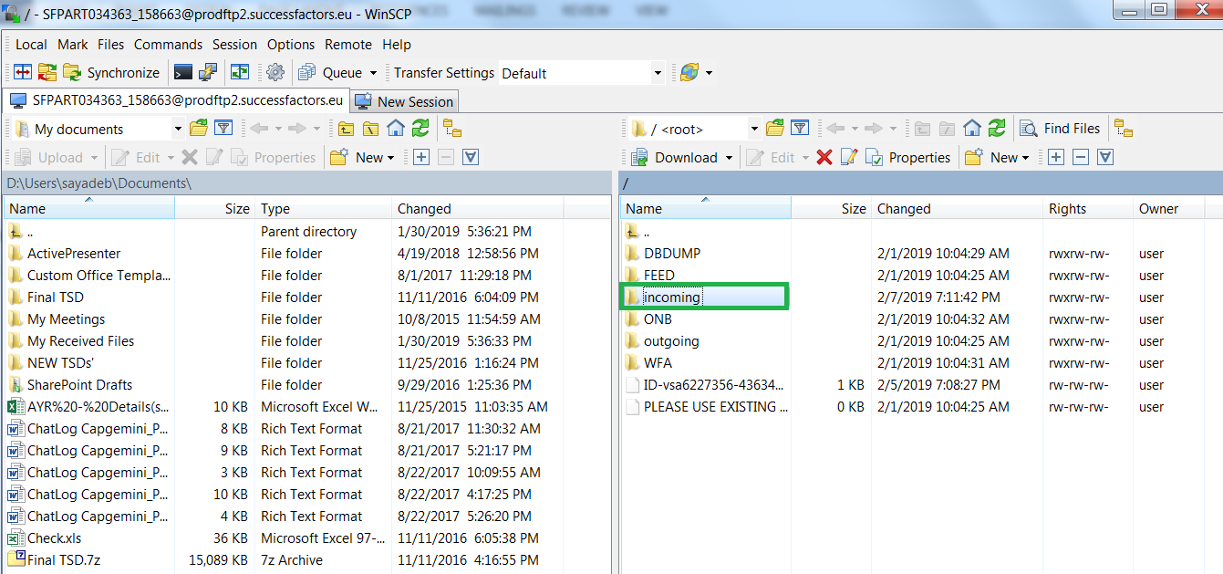

**Step 31:** Create Sender Directory. Click on ***‘New’*** and select ***‘Directory’*** from the drop down list.

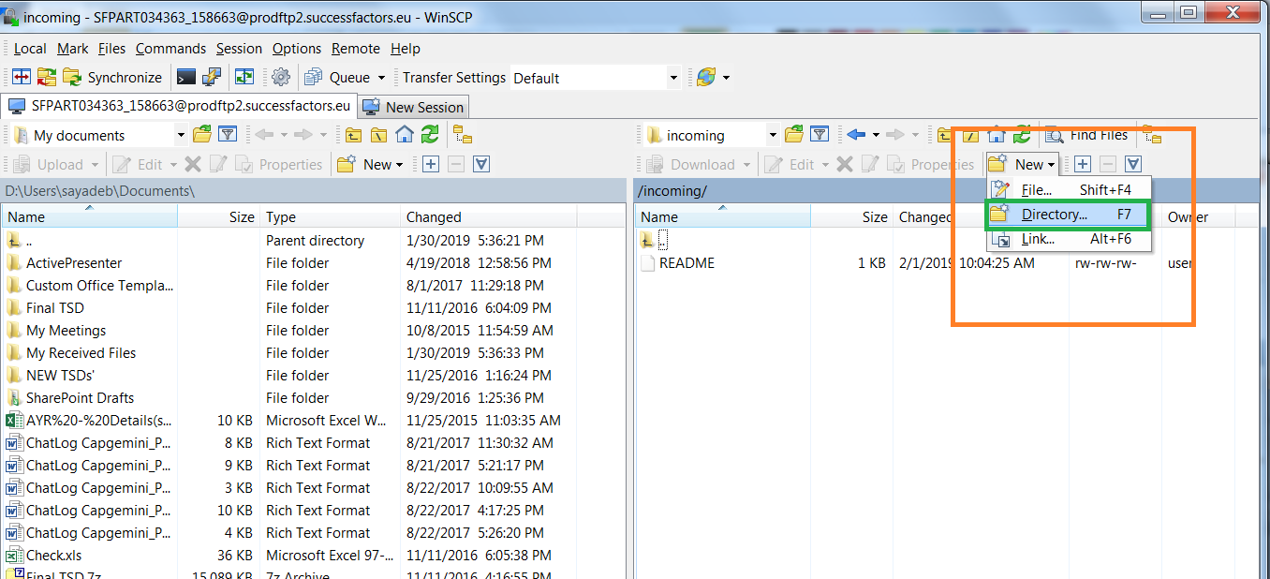

**Step 32:** Name the directory as Sender (it should be same as the name mentioned in the ***SOAP Sender Adapter>>Source Tab>>File Access Parameters>>Directory***). Click on ***‘OK’***.

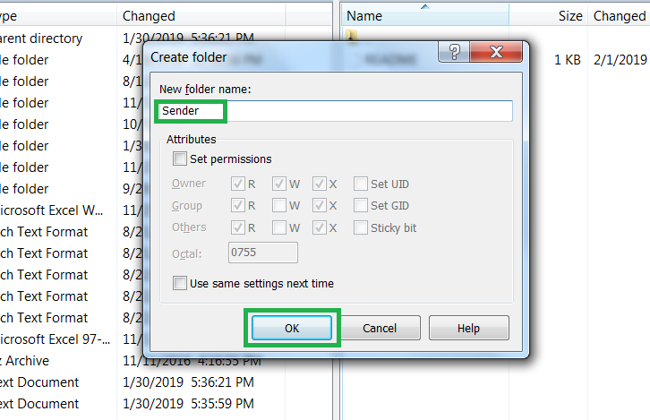

**Step 33:** The source directory named ***‘Sender’*** is created.

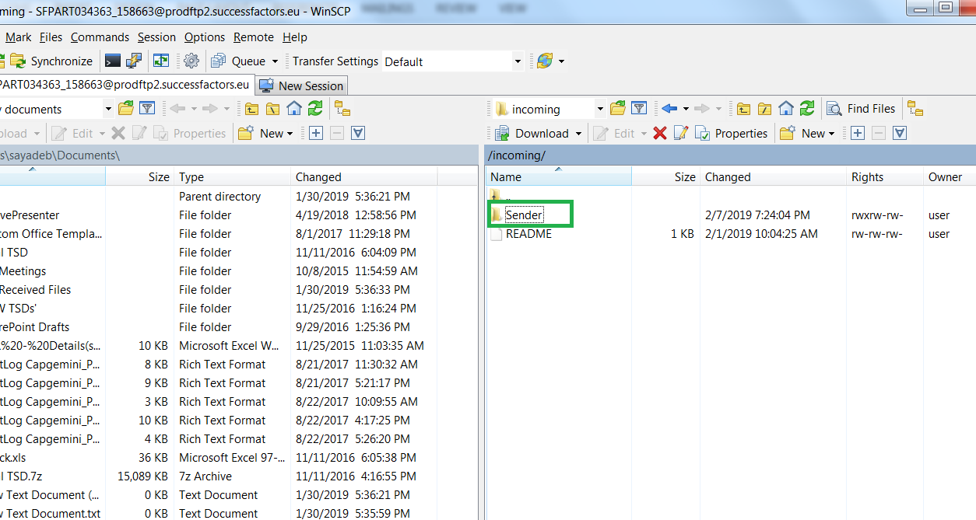

**Step 34:** Create ***‘Receiver’*** naming Receiver Directory same we did in previous steps. Click on ***‘OK’***.

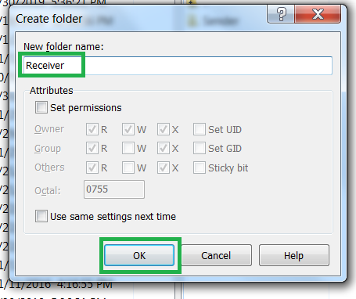

**Step 35:** The source directory named ***‘Receiver’*** is created.

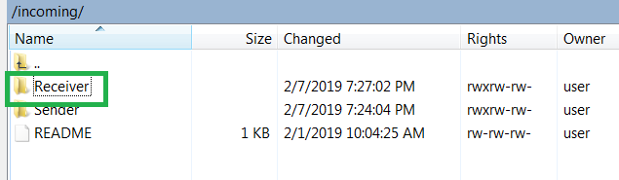

**Step 36:** Create a test ***.xml*** file to place in the Sender Directory to be picked. The name should be same as the name mentioned in the SFTP Sender and Receiver Adapters. Here, the name you have taken as ***‘Test_File.xml***

**Sample Test File**



**Step 37:** Go to the sender SFTP Adapter (Step 13). Go to ***‘Scheduler’*** tab and select the ***‘Schedule on Day’*** radio-button. Give **today’s date**. Give 5-10 minutes later **time** in the ***‘On Time’*** field (because it takes a bit of time for the IFLOW to deploy and start and activate).

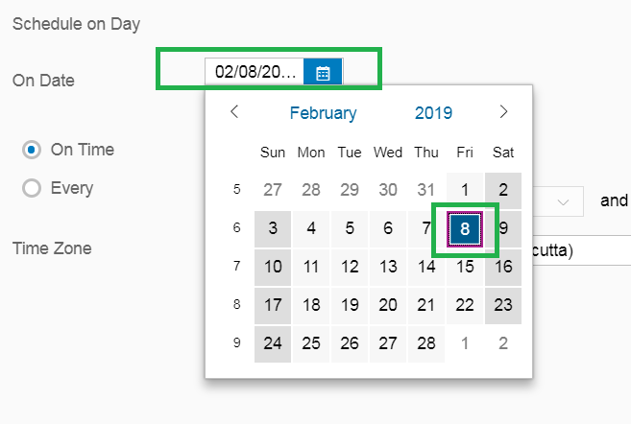

Current Time:



Select time 5-10mins later the current time.

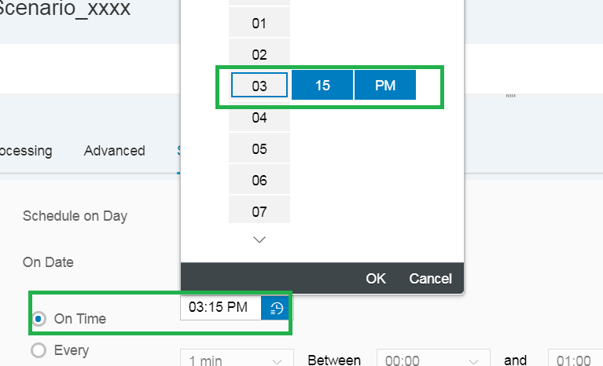

Also, select **Asia, Kolkata Time Zone** from the drop down list of ***‘Time Zone’***.

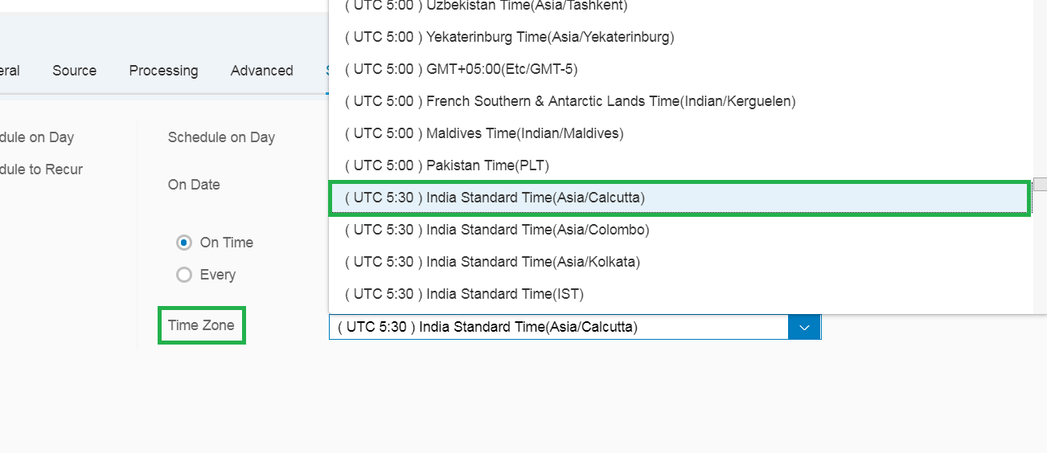

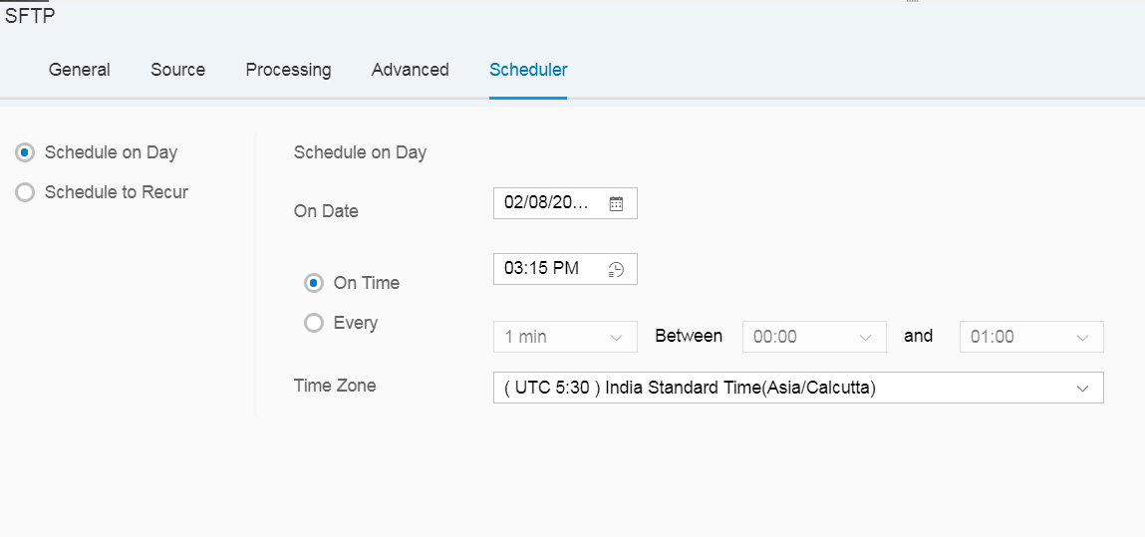

**Step 38:**  Follow **Step 25** to save the IFLOW.

**Step 39:** Go to WinSCP and place you’re the test file from your local desktop and drop to the ***‘Sender Directory’***

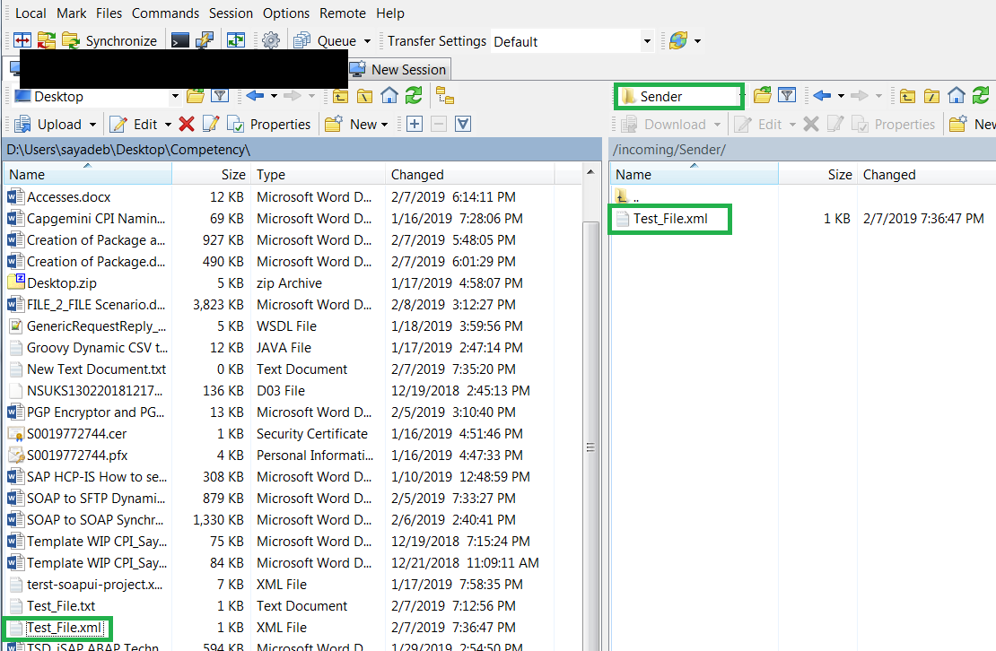

**Step 40:** You drag and drop the Test_File.xml from right to left window pane to upload the file in the ***‘Sender Directory’***.

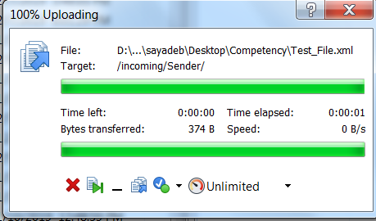

There it is! The file has been uploaded.

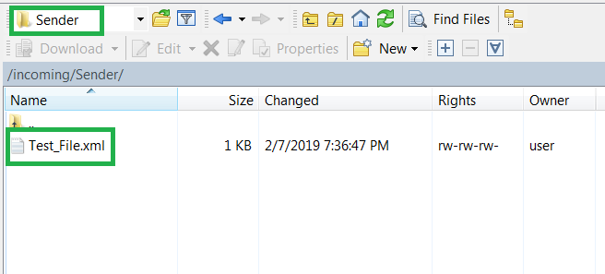

**Step 41:** After the mentioned time in the sender SFTP Adapter. Check in the WinSCP Sender Directory and click on refresh as highlighted in green on top right.

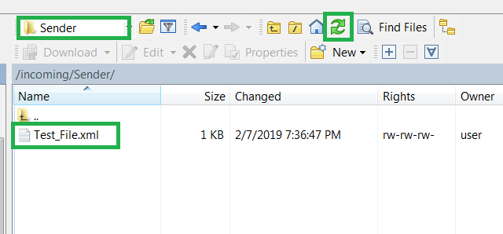

**Step 42:** After the refresh, you won’t find the file in the Sender Directory as it has been picked up after the deployment happens.

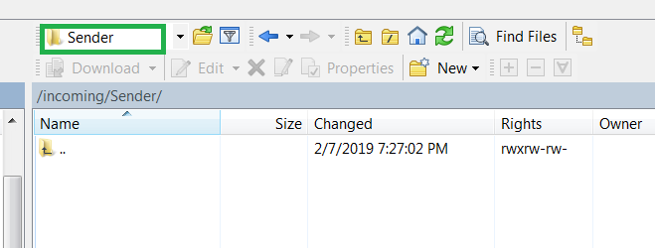

**Step 43:** Now check if the file is in Receiver Directory. Click on ***‘Incoming’*** from the drop down list.

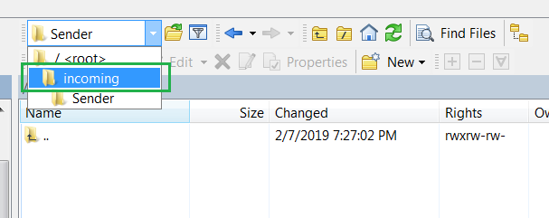

**Step 44:** Click on the ***‘Receiver’*** Directory to go into it.

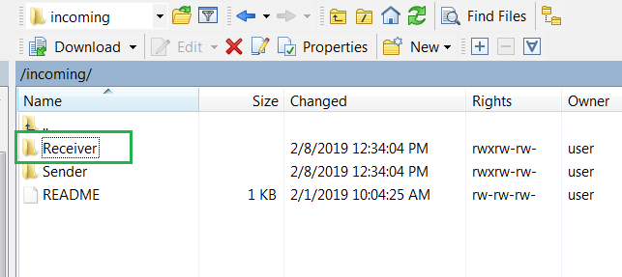

**Step 45:** You can’t see the file until you refresh. So click on the green highlighted ***‘Refresh’*** on top right of the page.

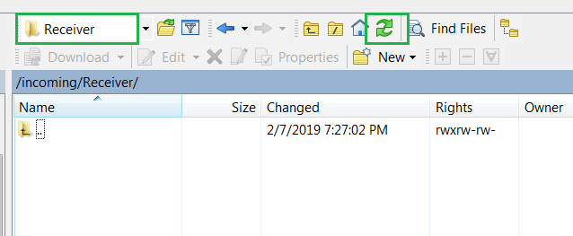

There it is! The ***‘Test_File.xml’*** as expected.

